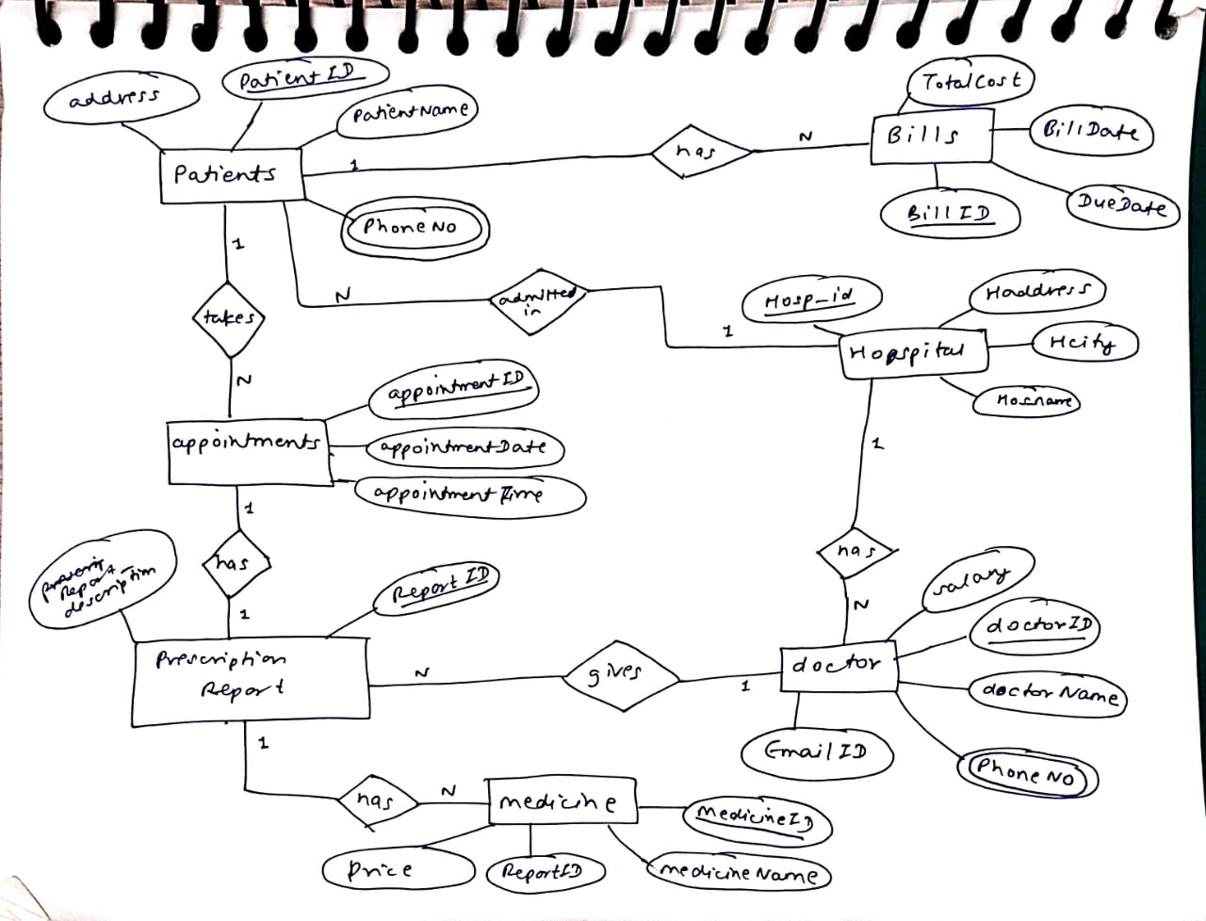**Assignment 8 Question no 1. 2k21/CO/417 Sandesh Shrestha**

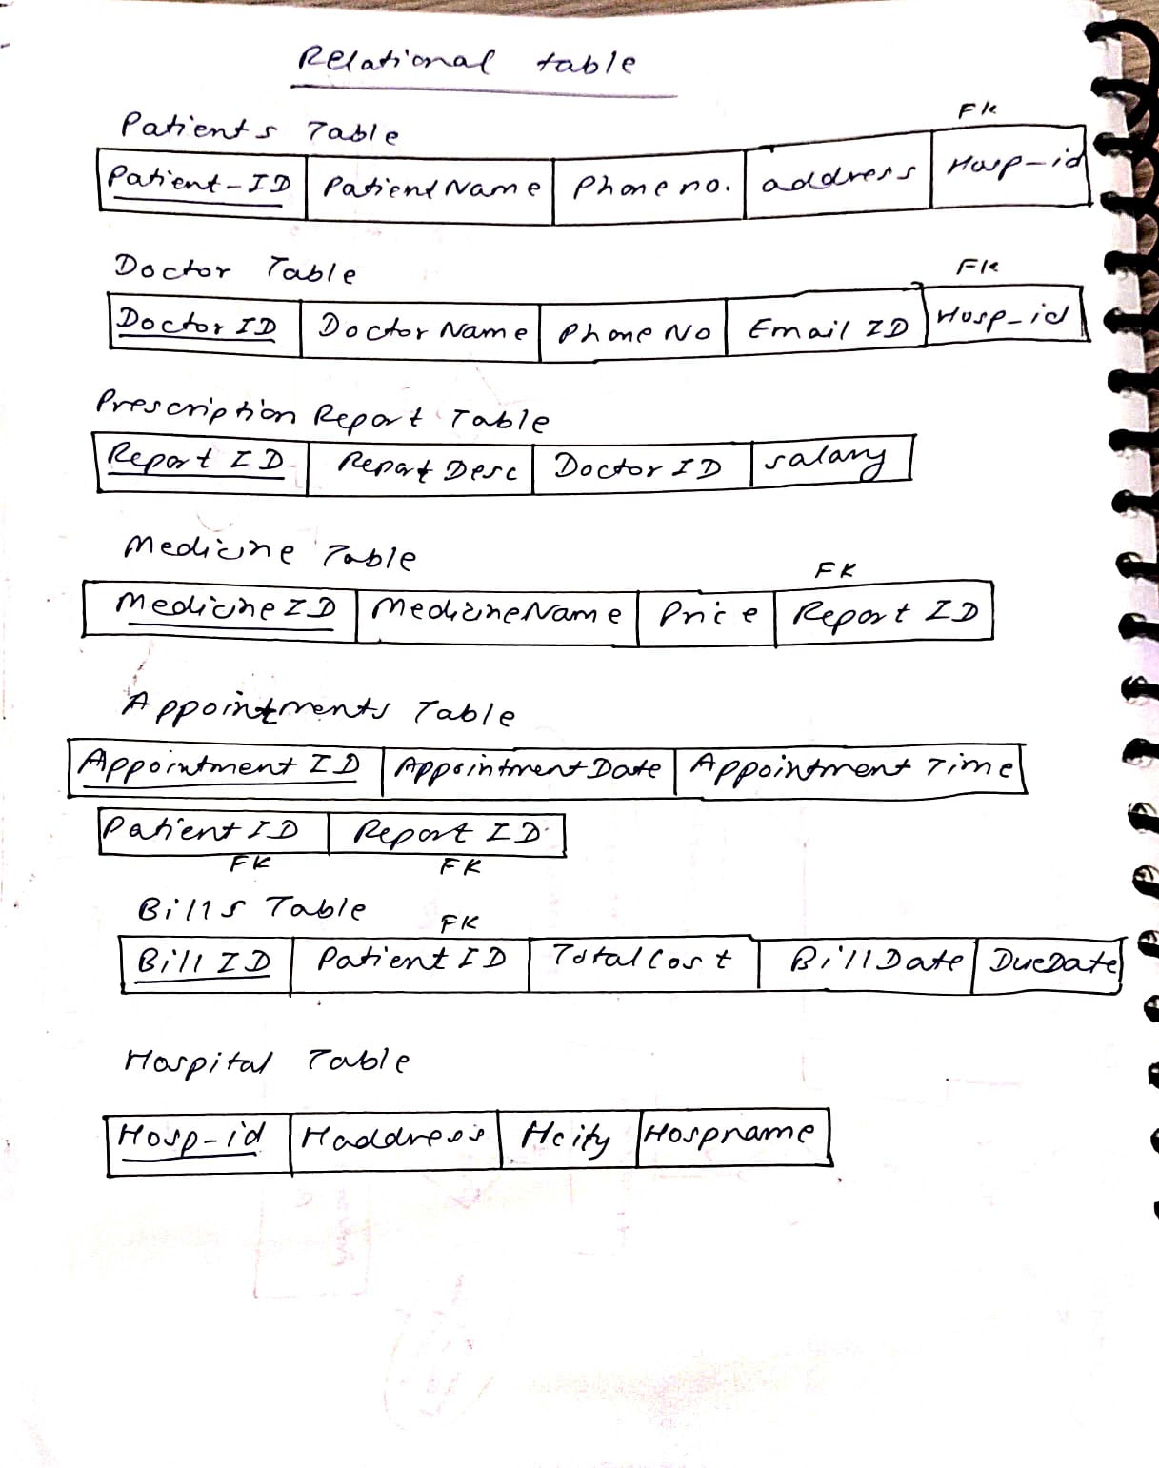

**CREATE** TABLE Patients(

PatientID NUMBER PRIMARY KEY,

PatientName VARCHAR2(50) NOT NULL,

Address VARCHAR2(50) NOT NULL,

PhoneNo VARCHAR2(50) NOT NULL

);

CREATE TABLE Doctor(

DoctorID NUMBER(10) PRIMARY KEY,

DoctorName VARCHAR2(50) NOT NULL,

PhoneNo VARCHAR2(50) UNIQUE,

EmailID VARCHAR2(50) UNIQUE);

CREATE TABLE PrescriptionReport(

ReportID NUMBER(10) PRIMARY KEY,

ReportDescription VARCHAR2(255) DEFAULT 'General Checkup',

DoctorID NUMBER(10),

FOREIGN KEY(DoctorID) REFERENCES Doctor(DoctorID));

CREATE TABLE Medicine(

MedicineID NUMBER(10) PRIMARY KEY,

MedicineName VARCHAR2(255) NOT NULL,

Price VARCHAR2(255) NOT NULL,

ReportID NUMBER(10),

FOREIGN KEY(ReportID) REFERENCES PrescriptionReport(ReportID)

);

CREATE TABLE Appointments(

AppointmentID NUMBER(10) PRIMARY KEY,

AppointmentDate DATE NOT NULL,

AppointmentTime VARCHAR2(30) NOT NULL,

PatientID NUMBER(10),

ReportID NUMBER(10),

FOREIGN KEY(PatientID) REFERENCES Patients(PatientID),

FOREIGN KEY(ReportID) REFERENCES PrescriptionReport(ReportID));

CREATE TABLE Bills (

BillID NUMBER(10) PRIMARY KEY,

PatientID NUMBER(10) NOT NULL,

TotalCost NUMBER(10, 2) NOT NULL,

BillDate DATE NOT NULL,

DueDate DATE,

FOREIGN KEY (PatientID) REFERENCES Patients (PatientID)

);

INSERT ALL

INTO Patients(PatientID, PatientName, Address, PhoneNo) VALUES (1, 'Liam Johnson', '123 Main St, Anytown', '123-456-7890')

INTO Patients(PatientID, PatientName, Address, PhoneNo) VALUES (2, 'Ava Smith', '456 Oak Ave, Another Town', '555-555-1234')

INTO Patients(PatientID, PatientName, Address, PhoneNo) VALUES (3, 'Noah Davis', '789 Pine Rd, Big City', '111-222-3333')

INTO Patients(PatientID, PatientName, Address, PhoneNo) VALUES (4, 'Sophia Rodriguez', '321 Maple Dr, Smallville', '444-555-6666')

INTO Patients(PatientID, PatientName, Address, PhoneNo) VALUES (5, 'William Brown', '987 Cherry Ln, Metropolis', '777-888-9999')

INTO Patients(PatientID, PatientName, Address, PhoneNo) VALUES (6, 'Isabella Wilson', '654 Elm St, Gotham', '333-444-5555')

INTO Patients(PatientID, PatientName, Address, PhoneNo) VALUES (7, 'James Lee', '246 5th Ave, Springfield', '888-999-0000')

INTO Patients(PatientID, PatientName, Address, PhoneNo) VALUES (8, 'Olivia Perez', '135 Broadway, Capital City', '222-333-4444')

INTO Patients(PatientID, PatientName, Address, PhoneNo) VALUES (9, 'Oliver Martin', '864 High St, Atlantis', '111-222-3333')

INTO Patients(PatientID, PatientName, Address, PhoneNo) VALUES (10, 'Lalu Yadav', 'Bihar', '987-634-259')

INTO Patients(PatientID, PatientName, Address, PhoneNo) VALUES (11, 'Rahul Sharma', 'Delhi', '767-473-5890')

INTO Patients(PatientID, PatientName, Address, PhoneNo) VALUES (12, 'Aman Yadav', 'Delhi', '858-7848-789')

INTO Patients(PatientID, PatientName, Address, PhoneNo) VALUES (13, 'Sameer Saxena', 'Mumbai', '838-146-7671')

INTO Patients(PatientID, PatientName, Address, PhoneNo) VALUES (14, 'Akash Chopra', 'Goa', '734-932-1587')

INTO Patients(PatientID, PatientName, Address, PhoneNo) VALUES (15, 'Emma Thompson', '579 Low St, Neverland', '555-444-3333')

SELECT 1 FROM dual;

INSERT ALL

INTO Doctor(DoctorID, DoctorName, PhoneNo, EmailID) VALUES(1, 'Dr. Jackson', '555-123-4567', 'jackson@hospital.com')

INTO Doctor(DoctorID, DoctorName, PhoneNo, EmailID) VALUES(2, 'Dr. Smith', '555-234-5678', 'smith@hospital.com')

INTO Doctor(DoctorID, DoctorName, PhoneNo, EmailID) VALUES(3, 'Dr. Patel', '555-345-6789', 'patel@hospital.com')

INTO Doctor(DoctorID, DoctorName, PhoneNo, EmailID) VALUES(4, 'Dr. Chen', '555-456-7890', 'chen@hospital.com')

INTO Doctor(DoctorID, DoctorName, PhoneNo, EmailID) VALUES(5, 'Dr. Kim', '555-567-8901', 'kim@hospital.com')

SELECT * FROM dual;

INSERT ALL

INTO PrescriptionReport(ReportID, ReportDescription, DoctorID) VALUES(1, 'Leg Injury', 1)

INTO PrescriptionReport(ReportID, ReportDescription, DoctorID) VALUES(2, 'Heart Attack', 4)

INTO PrescriptionReport(ReportID, ReportDescription, DoctorID) VALUES(3, 'Broken Teeth', 5)

INTO PrescriptionReport(ReportID, ReportDescription, DoctorID) VALUES(4, 'Typhoid', 2)

INTO PrescriptionReport(ReportID, ReportDescription, DoctorID) VALUES(5, 'Fever and Commoncold', 3)

INTO PrescriptionReport(ReportID, ReportDescription, DoctorID) VALUES(6, 'Hand Injury', 1)

SELECT * FROM dual;

INSERT ALL

INTO Medicine(MedicineID, MedicineName, Price, ReportID) VALUES(1, 'Aspirin', 'Rs.200', 1)

INTO Medicine(MedicineID, MedicineName, Price, ReportID) VALUES(2, 'Vasoter', 'Rs.250', 2)

INTO Medicine(MedicineID, MedicineName, Price, ReportID) VALUES(3, 'Avandia', 'Rs.300', 2)

INTO Medicine(MedicineID, MedicineName, Price, ReportID) VALUES(4, 'OraGel', 'Rs.179', 3)

INTO Medicine(MedicineID, MedicineName, Price, ReportID) VALUES(5, 'Ceftriaxone', 'Rs.200', 4)

INTO Medicine(MedicineID, MedicineName, Price, ReportID) VALUES(6, 'Vivotif', 'Rs.250', 4)

INTO Medicine(MedicineID, MedicineName, Price, ReportID) VALUES(7, 'Paracetamol', 'Rs.60', 5)

INTO Medicine(MedicineID, MedicineName, Price, ReportID) VALUES(8, 'Moov', 'Rs.70', 6)

SELECT * FROM dual;

INSERT ALL

INTO Appointments(AppointmentID, AppointmentDate, AppointmentTime, PatientID, ReportID)

VALUES(1, TO_DATE('2022-04-11', 'YYYY-MM-DD'), '10AM', 1, 1)

INTO Appointments(AppointmentID, AppointmentDate, AppointmentTime, PatientID, ReportID)

VALUES(2, TO_DATE('2022-04-13', 'YYYY-MM-DD'), '10AM', 2, 2)

INTO Appointments(AppointmentID, AppointmentDate, AppointmentTime, PatientID, ReportID)

VALUES(3, TO_DATE('2022-04-09', 'YYYY-MM-DD'), '10AM', 3, 3)

INTO Appointments(AppointmentID, AppointmentDate, AppointmentTime, PatientID, ReportID)

VALUES(4, TO_DATE('2022-04-08', 'YYYY-MM-DD'), '10AM', 4, 4)

INTO Appointments(AppointmentID, AppointmentDate, AppointmentTime, PatientID, ReportID)

VALUES(5, TO_DATE('2022-04-13', 'YYYY-MM-DD'), '10AM', 5, 5)

INTO Appointments(AppointmentID, AppointmentDate, AppointmentTime, PatientID, ReportID)

VALUES(6, TO_DATE('2022-04-20', 'YYYY-MM-DD'), '10AM', 1, 6)

SELECT 1 FROM dual;

INSERT ALL

INTO Bills (BillID, PatientID, TotalCost, BillDate, DueDate) VALUES (1, 2, 100.00, TO_DATE('2023-03-01', 'YYYY-MM-DD'), TO_DATE('2023-03-31', 'YYYY-MM-DD'))

INTO Bills (BillID, PatientID, TotalCost, BillDate, DueDate) VALUES (2, 3, 250.00, TO_DATE('2023-03-01', 'YYYY-MM-DD'), TO_DATE('2023-03-31', 'YYYY-MM-DD'))

INTO Bills (BillID, PatientID, TotalCost, BillDate, DueDate) VALUES (3, 4, 75.50, TO_DATE('2023-03-01', 'YYYY-MM-DD'), TO_DATE('2023-03-31', 'YYYY-MM-DD'))

INTO Bills (BillID, PatientID, TotalCost, BillDate, DueDate) VALUES (4, 5, 500.00, TO_DATE('2023-03-01', 'YYYY-MM-DD'), TO_DATE('2023-03-31', 'YYYY-MM-DD'))

INTO Bills (BillID, PatientID, TotalCost, BillDate, DueDate) VALUES (5, 1, 1000.00, TO_DATE('2023-03-01', 'YYYY-MM-DD'), TO_DATE('2023-03-31', 'YYYY-MM-DD'))

INTO Bills (BillID, PatientID, TotalCost, BillDate, DueDate) VALUES (6, 6, 200.00, TO_DATE('2023-03-01', 'YYYY-MM-DD'), TO_DATE('2023-03-31', 'YYYY-MM-DD'))

SELECT * FROM dual;

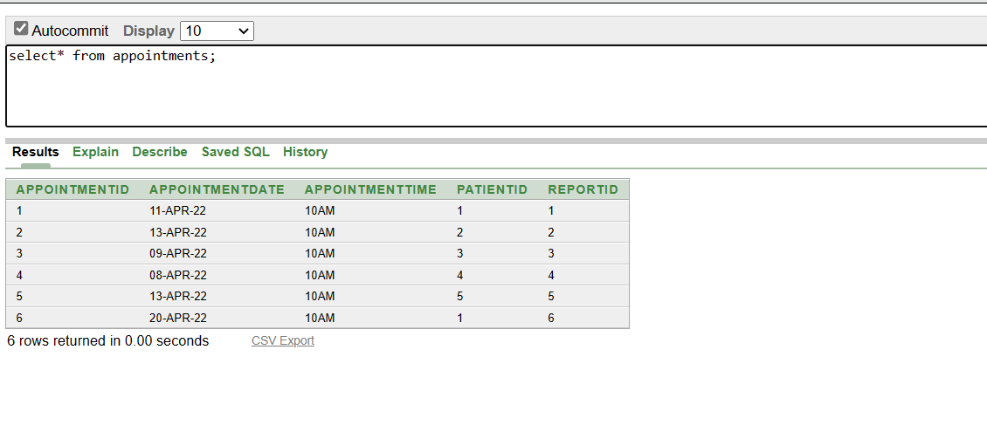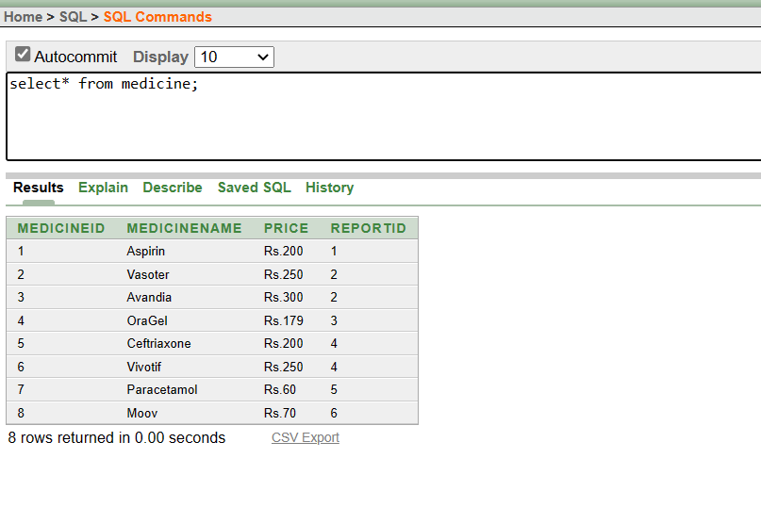**Some sample Select commands in oracle:**

